Lab 9.1 - Using Databricks to Run a Recommendation System with MLLib & Spark

# Step 1: Create a notebook

A notebook is a collection of cells that run computations on an Apache Spark cluster. There can be multiple workspaces in one cluster. To create a notebook in the Workspace:

1. In the sidebar, click the **Workspace** button Workspace Icon.
2. In the Workspace folder, select Down Caret **Create > Notebook**.

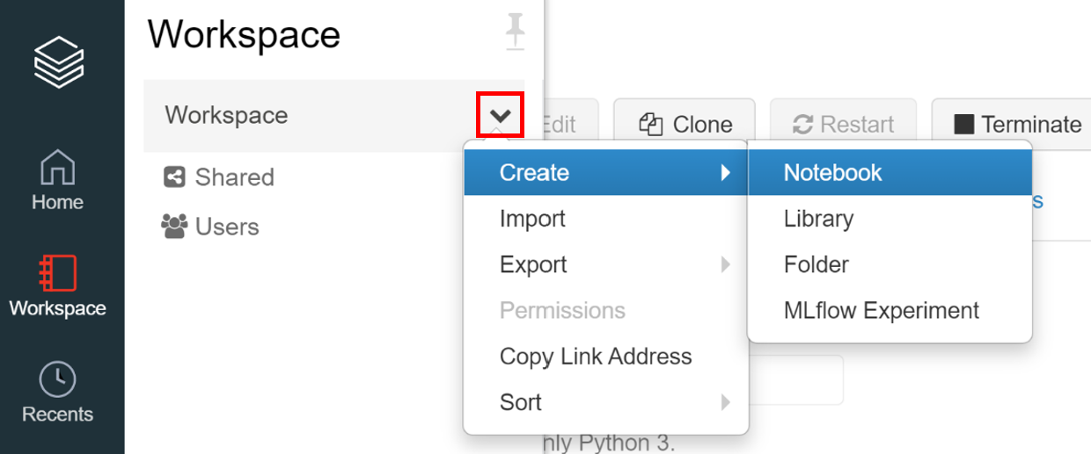

1. On the Create Notebook dialog, enter a name and select **Python** in the Language drop-down. This selection determines the default language of the notebook. Make sure the **Cluster** is the **Quickstart** cluster created in our Get Started file.

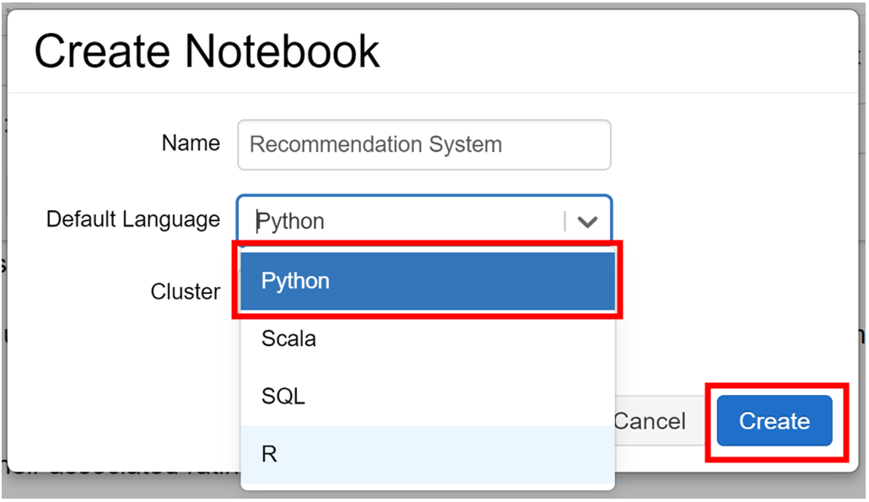

1. Click **Create**. The notebook opens with an empty cell at the top.

# Step 2: Clear widgets if any exist

Copy and paste this code snippet into a notebook cell:

# Clear widgets if any exist

dbutils.widgets.removeAll()

# Step 3: Ingest Movie Data to Notebook

Create the ratings and movies tables using the [Databricks Guide > Create a table using the UI](https://docs.databricks.com/user-guide/tables.html#create-a-table-using-the-ui)

1. In the sidebar, click the **Data** button .
2. In the Data folder, select **Add Data**.

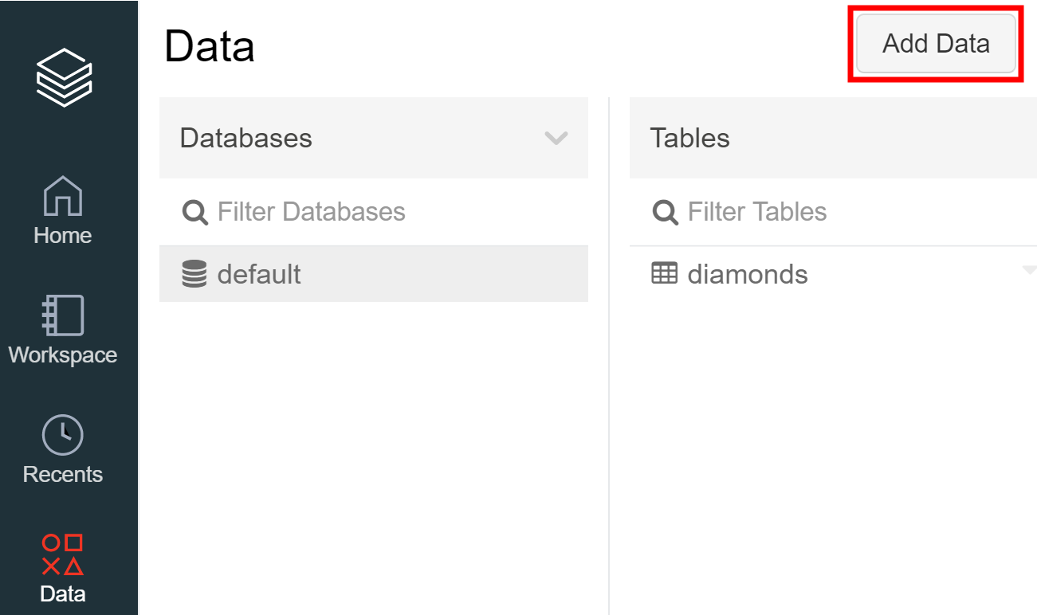

1. Keep the data source as Upload File and name the **DBFS Target Directory** as ‘movies’ (Table names can only contain lowercase alphanumeric characters and underscores and must start with a lowercase letter or underscore).

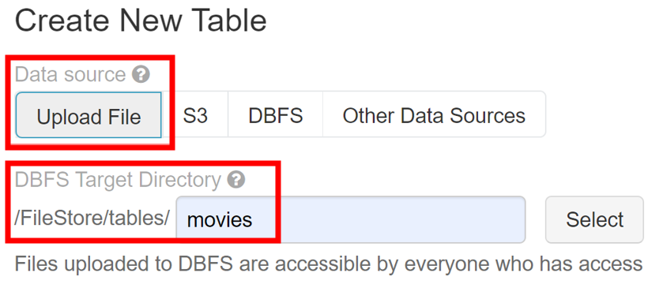

1. Drag file ‘movies.csv’ to the file drop zone or click the dropzone to browse to and choose files. After upload, a path displays for each file. The path will be something like /FileStore/tables/<filename>-<random-number>.<file-type> and you use this path in a notebook to read data.

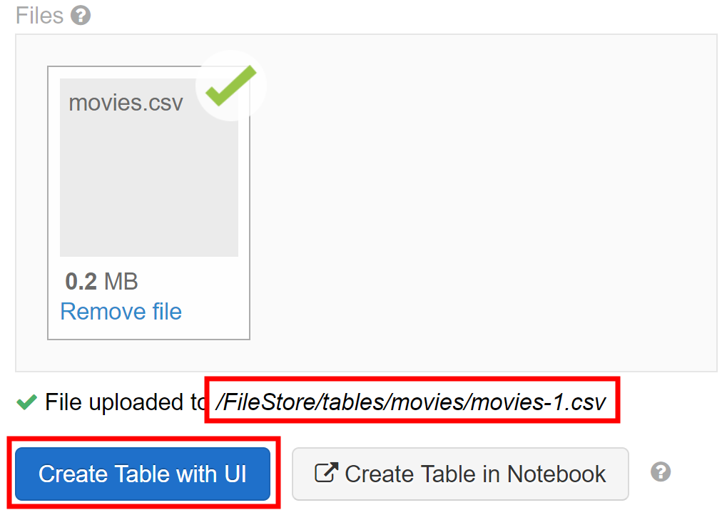

1. Click **Create Table with UI**.
2. In the Cluster drop-down, choose a cluster, then click **Preview Table**.

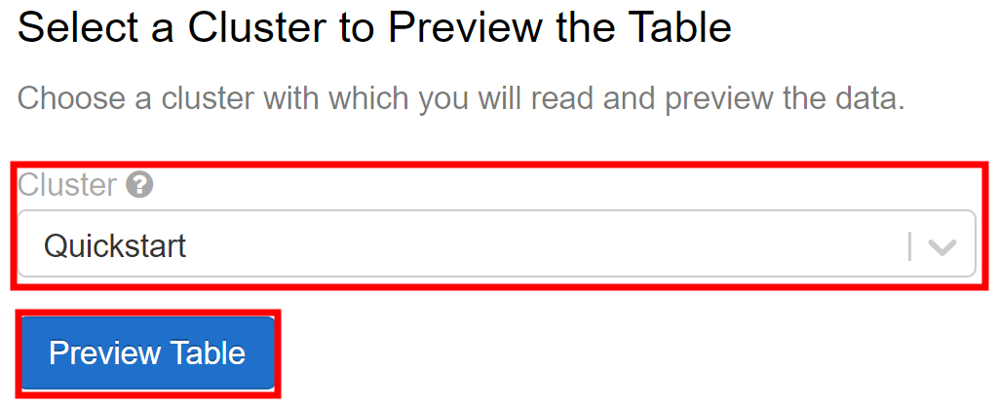

1. In the specify Table Attributes part, change the **Table Name** to ‘movies’. Check the **First row is header** box. Then change the data type for ‘id’ and ‘year’ to **INT in the drop-down.**

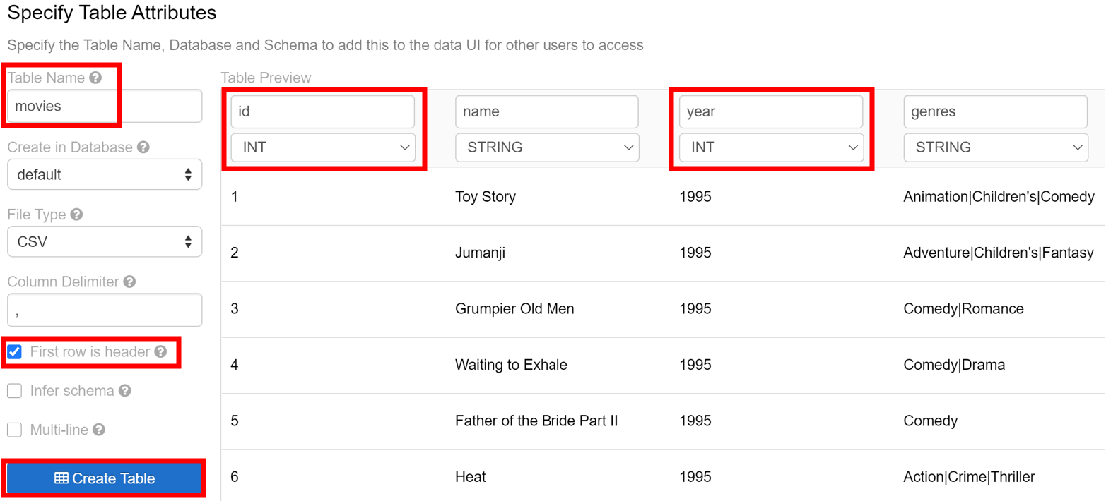

1. Click **Create Table**.
2. Click the **Data** button in the side bar and select **Add Data** again. Name the DBFS Target Directory as ‘ratings’. Drag ‘ratings.csv’ to the drop zone. Then click **Create Table with UI**, choose a cluster and click **Preview Table**. Change **Table Name** to ‘ratings’, check the **First row is header** box then change all the data type to **INT**. At last, click **Create Table**.

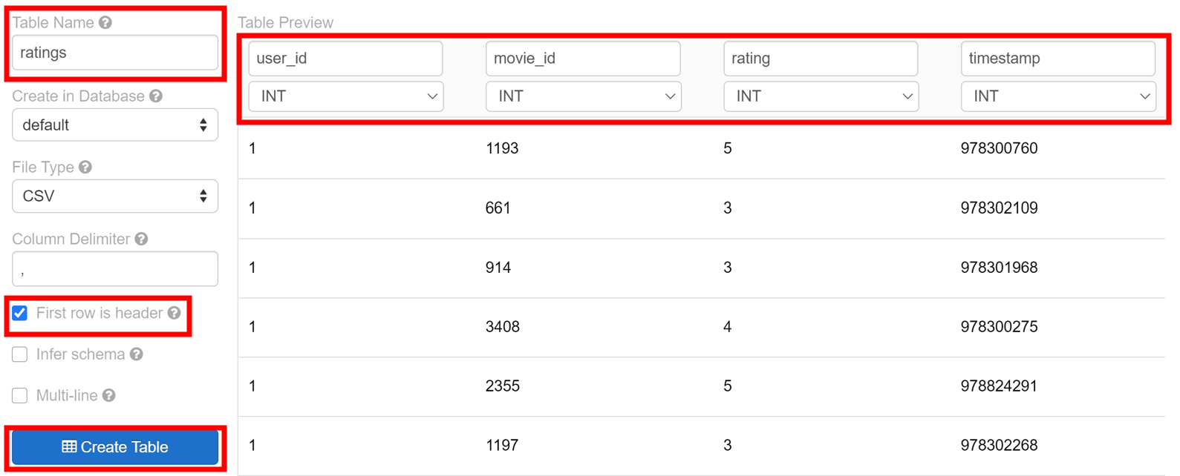

# Step 4: Configure Databricks Widgets

* The code snippet below will select 10 random movies out of the 200 topmost rated movies
* You will use **Databricks Widgets** to personalize your movie ratings. Go back to your databricks notebook and paste the following code chunk:

spark.sql("""

select

movie_id, movies.name, count(*) as times_rated

from

ratings

join

movies on ratings.movie_id = movies.id

group by

movie_id, movies.name, movies.year

order by

times_rated desc

limit

200

"""

).createOrReplaceTempView("most_rated_movies")

# Take a sample of 10 movies

most_rated_movies_sample = spark.table("most_rated_movies").rdd.takeSample(**True**, 10)

# Update widgets with movies for you to rate

**for** i **in** range(0, len(most_rated_movies_sample)):

dbutils.widgets.dropdown("movie_%i" % i, "5", ["1", "2", "3", "4", "5"], most_rated_movies_sample[i].name)

# Step 5: Personalize Your Movie Ratings with Databricks Widgets

Change the values on top to be your own personal ratings before proceeding. Right now they’re all 5 but you should change it into arbitrary values.

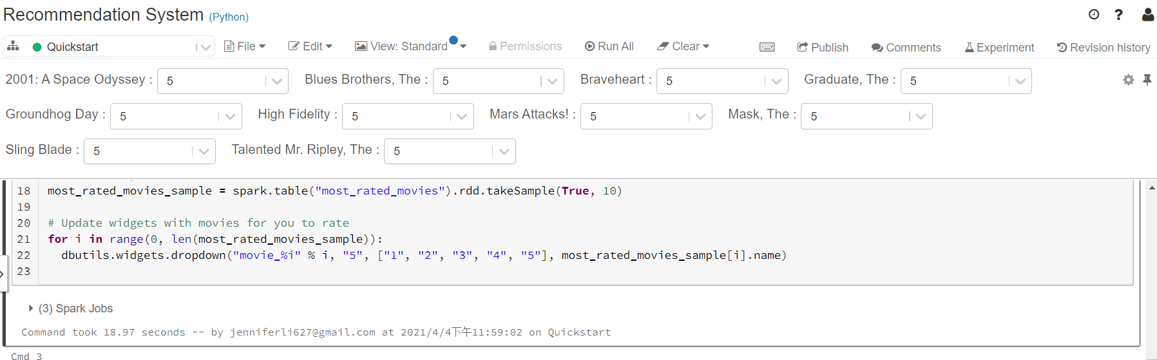

For example, I change it as follows:



The following code snippet will process your personal movie ratings.

# Create DataFrame based on your own personal ratings

**from** datetime **import** datetime

**from** pyspark.sql **import** Row

ratings = []

**for** i **in** range(0, len(most_rated_movies_sample)):

ratings.append(

Row(user_id = 0,

movie_id = most_rated_movies_sample[i].movie_id,

rating = float(dbutils.widgets.get("movie_%i" %i))

)

)

myRatingsDF = spark.createDataFrame(ratings)

# Create myRatings DataFrame with specific column order to match `ratings`

myRatings = myRatingsDF.select("user_id", "movie_id", "rating")

myRatings.createOrReplaceTempView("myRatings")

%sql

-- Display your ratings

**select** f.movie_id, m.name, f.rating **from** myRatings f **inner** **join** most_rated_movies m **on** m.movie_id = f.movie_id

The output should look like this:

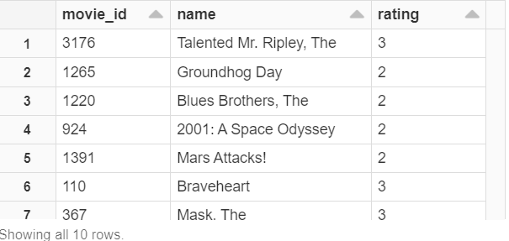

# Step 6: Create Training and Test Datasets for our ALS model

The following code snippet will split the dataset into training and testing datasets by 8/2 ratio.

**from** pyspark.sql **import** functions

ratings = spark.table("ratings")

ratings = ratings.withColumn("rating", ratings.rating.cast("float"))

ratings = ratings.drop("timestamp")

# Split our data for our training and test datasets

(training, test) = ratings.randomSplit([0.8, 0.2])

# Step 7: Create ALS Model on Training (and Personalized) Data

The following code snippet will create a ALS collaborative model based on training and personalized data.

**from** pyspark.ml.recommendation **import** ALS

# Run ALS collaborative filtering

als = ALS(maxIter=5, regParam=0.01, userCol="user_id", itemCol="movie_id", ratingCol="rating")

# Run training model which includes your own ratings

model = als.fit(training.unionAll(myRatings))

# Step 8: Review ALS Model Predictions Using Test Dataset

The following code snippet will display the result of the ALS model created in Step 7.

predictions = model.transform(test).dropna()

predictions.createOrReplaceTempView("predictions")

display(predictions)

The output should look like this:

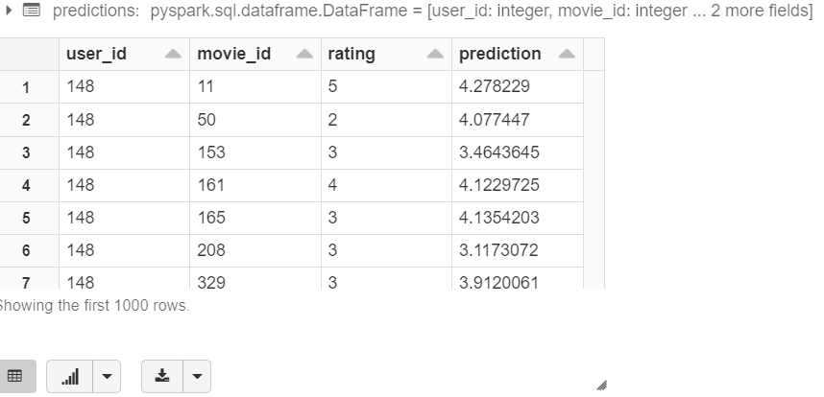

Note that your number might be different from mine, since it depends on how you input the ratings in step 5

# Step 9: Evaluate the Model

The following code snippet will evaluate the ALS model created in Step 7 by its RMSE (Root Mean Squard Error). Small RMSE stands for high accuracy.

# Evaluate the model

**from** pyspark.ml.evaluation **import** RegressionEvaluator

evaluator = RegressionEvaluator(metricName="rmse", labelCol="rating", predictionCol="prediction")

rmse = evaluator.evaluate(predictions)

# Display using `displayHTML`

displayHTML("<span style='font-size:14pt;color:purple'>The Root Mean Square Error is %s</span>" % str(rmse))

The output should look like this:



Note that your number might be different from mine, since it depends on how you input the ratings in step 5

# Step 10: How well does the ALS Model Predict You?

The following code snippet will display how the ALS model predict your personal ratings.

# Ensure the columns are the same order as the model is expecting

myRatings = myRatingsDF.select("user_id", "movie_id", "rating")

# Run the same ALS model on my personalized Ratings

myPersonalizedMovies = model.transform(myRatings).dropna()

myPersonalizedMovies.createOrReplaceTempView("myPersonalizedMovies")

# Display the model's predicted ratings

display(myPersonalizedMovies)

The output should look like this:

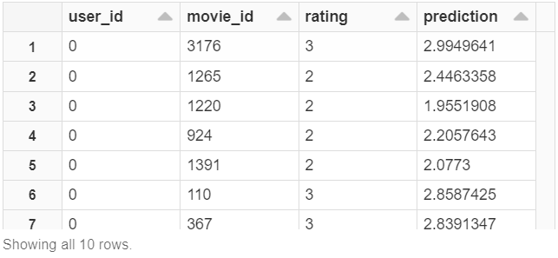

Note that your number might be different from mine, since it depends on how you input the ratings in step 5

The following code snippet will show the RMSE of ALS model predicting your personalized ratings.

# Evaluate model for my personalized ratings movies

my_rmse = evaluator.evaluate(myPersonalizedMovies)

# Display using `displayHTML`

displayHTML("<span style='font-size:14pt;color:purple'>The Root Mean Square Error is %s</span>" % str(my_rmse))

The output should look like this:



Note that your number might be different from mine, since it depends on how you input the ratings in step 5

# Step 11: Find My Top 10 Movies based on My Ratings

The following code snippet will show the top 10 movie the ALS model picked for you.

# Take the list of the movies you already rated (myRatings), the list of most_rated_movies (removing the ones you already rated)

# and assign them to yourself (user_id = 0)

sqlQuery = """

select null as user_id, null as movie_id, null as rating union all

select user_id, movie_id, rating from myRatings union all

select cast(0 as bigint) as user_id, movie_id, cast(0 as float) as rating from most_rated_movies where movie_id not in (select movie_id from myRatings)

"""

most_rated_movies_n = spark.sql(sqlQuery)

most_rated_movies_n.createOrReplaceTempView("most_rated_movies_n")

# Applying and then removing NULL to ensure original ratings and most_rated_movies_0 schema match

most_rated_movies_0 = spark.sql("select * from most_rated_movies_n where user_id = 0")

# Re-apply our ALS model for all movies

movies_predicted_0 = model.transform(most_rated_movies_0).dropna()

movies_predicted_0.createOrReplaceTempView("movies_predicted_0")

display(movies_predicted_0)

%sql

-- Show Your Top 10 movies

**select** m.name, f.prediction

**from** movies_predicted_0 f

**inner** **join** most_rated_movies m

**on** m.movie_id = f.movie_id

**order** **by** f.prediction **desc**

**limit** 10

The output should look like this:

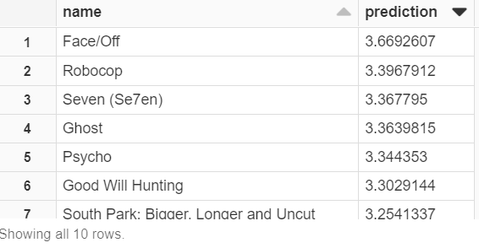

Note that your number might be different from mine, since it depends on how you input the ratings in step 5